**“RESTAURANT WEBSITE”**

**Mini Project Report 2-B**

Submitted in partial fulfillment of the requirements for

**Third year of Engineering (Computer Engineering)**

**By**

Karishma Apparao Bairi TU3F1920014

Ketki Milind Kulkarni TU3F1920053

Shweta Madhukar Kaware TU3F1920005

Nupoora Deepak Shinde TU3F1920021

Under the Guidance of

**Prof. Kishor Sakure**



**Department of Computer Engineering TERNA ENGINEERING COLLEGE**

Nerul (W), Navi Mumbai 400706

(University of Mumbai)

(2021-2022)

**Internal Approval Sheet**



**TERNA ENGINEERING COLLEGE, NERUL**

**Department of Computer Engineering**

Academic Year 2021-22

**CERTIFICATE**

This is to certify that the project entitled **“RESTAURANT WEBSITE”** is a bonafide work of

Karishma Apparao Bairi TU3F1920014

Ketki Milind Kulkarni TU3F1920053

Shweta Madhukar Kaware TU3F1920005

Nupoora Deepak Shinde TU3F1920021

submitted to the University of Mumbai in partial fulfilment of the requirement

for the Third year of Engineering. (Computer Engineering).

**Guide Project Convener Head of Department Principal**

**Approval Sheet**

Project Report Approval

This Project Report – A entitled **“RESTAURANT WEBSITE”** by following students is approved for T.E. in "Computer Engineering".

***Submitted by:***

Karishma Apparao Bairi TU3F1920014

Ketki Milind Kulkarni TU3F1920053

Shweta Madhukar Kaware TU3F1920005

Nupoora Deepak Shinde TU3F1920021

Examiner’s Name & Signature:

1. ______________________
2. ______________________

Date:

Place:

**DECLARATION**

We declare that this written submission represents our proposal in our own words and where others ideas or words have not been included, we have suitably mentioned and referenced the original sources. We also declare that we have stuck to all principles of academic uprightness and integrity and have not misrepresented or created or falsified any idea/data/fact/source in our submission. We understand that any infraction of the above will be cause for disciplinary action by the Institute and can also call up penal action from the sources which have thus not been properly mentioned or from whom proper permission has not been taken when needed.

Karishma Apparao Bairi TU3F1920014 ---------------------------

Ketki Milind Kulkarni TU3F1920053 ---------------------------

Shweta Madhukar Kaware TU3F1920005 ---------------------------

Nupoora Deepak Shinde TU3F1920021 ---------------------------

Date:

Place:

**ACKNOWLEDGEMENT**

Project is never complete without the guidance of those expert who have already traded this past before, and hence become master of it and as a result, our leader. So, we would like to take this opportunity to take all those individuals who have helped us in visualizing this project.

We express our extensive gratitude to our project guide Mr. Kishor Sakure for providing timely assistant to our query and guidance that he gave owing to his experience in this field for past many years. He had indeed been a leading light for us in this journey.

We would also take this opportunity to thank our project coordinator Mrs. Priyanka Sherkhane for her guidance in selecting this project and also for providing us all this details on proper presentation of this project.

We extend our sincere appreciation to all our Professor from TERNA ENGINEERING COLLEGE for their valuable insight and tip during the designing of the project. Their contributions have been valuable in so many ways that we find it is difficult to acknowledge them individually.

We are also obliged to our HOD Mrs. Archana Mire for extending her help directly and indirectly through various channel in our project work.

We take the privilege to express our sincere thanks to Principal Dr. L. K. Ragha for providing encouragement and much support throughout our work.

Karishma Apparao Bairi TU3F1920014

Ketki Milind Kulkarni TU3F1920053

Shweta Madhukar Kaware TU3F1920005

Nupoora Deepak Shinde TU3F1920021

**Table of contents**

|  |  |  |
| --- | --- | --- |
| **Sr No.** | **Chapter** | **Page No.** |
| **1** | **Introduction** | **8** |
| **2** | **Literature Review** | **10** |
| **3** | **Methodology** | **12** |
| **4** | **Hardware & Software Requirements** | **21** |
| **5** | **Implementation** | **24** |
| **6** | **Results and Discussion** | **26** |
| **7** | **Conclusion** | **30** |
| **8** | **References** | **31** |

**ABSTRACT**

Restaurant Website is a web-based application that has a number of features that will allow users to order foods online. This system as well as the web application’s concept is all clear, it’s the same as real-life scenarios and well-implemented on it. This Food Order Management System Project focuses mainly on ordering food and managing food items. Also, the system displays all the lists of available food categories. In addition, the system allows managing food items too. Tools like HTML, CSS, JavaScript, PHP, SQL were used to develop the Restaurant Website.

**CHAPTER 1: INTRODUCTION**

The Restaurant Website Project in PHP focuses mainly on ordering food and managing food items. Also, the system displays all the lists of available food categories. In addition, the system allows managing food items too. The project is divided into two categories: Admin and Client-Side. In an overview of this web application, the user can simply look for available food items from the client-side. The website displays the top 3 food categories with recent food items. The customers can search for their own items too. For ordering an item, the customer has to select any of the items, enter quantity with customer information. The customer information includes his/her name, number, and billing address.

On the other hand, an admin has full control over the system. An admin has the right to manage the proper flow of the system. He/she can manage the food category by entering category names, photos, and selecting access features. After the management of categories, now the admin can insert food items into the menu. For this, an admin has to enter item name, description, price, photo, and select access features. These access features include whether the system will feature the item on the client-side as well as its active class. Now, after setting up everything, an admin can view all the food orders under the Orders section. All the orders that have been made from the client side are presented here.

Under the orders section, the system displays all the food orders with their respective names, dates, customer details, and status. The system represents such orders and differentiates them with different colors. Here, the user can change the order status from ordered to on deliver, canceled, or delivered. This section plays the main role in the calculation of total revenue. Also, the admin can manage system users for controlling the system. Besides, the admin can overview the records of a total number of categories, items, orders, canceled orders, pending orders. In addition to it, an admin can check for total revenue generated from the delivered food orders.

**1.1: AIM AND OBJECTIVE OF THE PROJECT**

**This system is developed to automate day to day activity of a restaurant. Restaurant is a kind of business that serves people all over world with ready-made food. This system is developed to provide service facility to restaurant and also to the customer. This restaurant website can be used by customers to place orders without any discrepancies.**

**1.2: SCOPE OF THE PROJECT**

**This restaurant website focuses on the development of an information system that will automate management of the restaurant.**

**It will take orders from the customer.**

**The website will display view of menu from which customer has to just select their desirable dish and add to cart.**

**The system will store and recognize customer reservations.**

**1.3: ORGANIZATION OF THE REPORT**

Chapter 1 contains brief introduction of our project with aim, objective and scope of the project.

Chapter 2 contains Literature Survey. In this chapter, we have studied and reviewed the previous work done on the topics related to our project. We have included different papers published by their respective authors.

Chapter 3 Methodology deals with the Block Diagram, Explanation of the Block Diagram, Modules of System and System Design Details.

Chapter 4 includes Hardware and Software Requirements of the project.

Chapter 5 includes the code of the project.

Chapter 6 contains screenshots of the output.

Chapter 7 is the conclusion of the project.Lastly, it has list of references.

**CHAPTER 2: LITERATURE REVIEW**

|  |  |  |  |
| --- | --- | --- | --- |
| **Year** | **Author Name** | **Paper Name** | **Description** |
| 2018 | Madhura M. Joshi | Automated Food Ordering System with Real - Time Customer Feedback | Since the recent revolutionary trend  has been made by the smartphones usage in which the  android is an operating system this platform is  helpful not only for the customers but they are useful  for administrators to manage their management. |
| 2016 | Mayur D. Jakhete | Implementation of  Smart Restaurant with E-Menu Card | This platform is made for the table  reservation as well as the food ordering system  simultaneously. |
| 2014 | Prajakta Kulkarni | Digital Table Booking and Food Ordering  System Using Android | In the past years the mobile usage and the computing has also brought a lot of change in the technology and the smartphones have been upgrading day by day alongwith making things work easy like our Food Ordering System. |
| 2012 | Eshan Gupta | Application on Order Management Systems in  Restaurant | Bringing a platform which provides food ordering was encouraged by the customers very much as well as the orders have been increasing day by day when compared to previous  years. |
| 2010 | Soon Nyean Cheong | Design and Development of Multi - Touchable E-Restaurant Management System | There has been drastic improvements  in the technology where we have got the online food  ordering system from remote areas as well known as  online food ordering application which makes easy for user to order food. |

**2.2: EXPLANATION OF LITERATURE PAPERS**

**Paper 1: Automated Food Ordering System with Real - Time Customer Feedback By Madhura M. Joshi**

In this paper the author says since the recent revolutionary trend has been made by the smartphones usage in which the android is an operating system this platform is helpful not only for the customers but they are useful for administrators to manage their management.

**Paper 2: Implementation of Smart Restaurant with E-Menu Card By Mayur D. Jakhete**

In this paper the author says that this platform is made for the table reservation as well as the food ordering system simultaneously.

**Paper 3: Digital Table Booking and Food Ordering System Using Android by Prajakta Kulkarni**

In this paper the author says that in the past years the mobile usage and the computing has also brought a lot of change in the technology and the smartphones have been upgrading day by day along with making things work easy like our Food Ordering System.

**Paper 4: Application on Order Management Systems in Restaurant By Eshan Gupta**

In this paper the author says that bringing a platform which provides food ordering was encouraged by the customers very much as well as the orders have been increasing day by day when compared to previous years.

**Paper 5: Design and Development of Multi - Touchable E-Restaurant Management System by Soon Nyean Cheong**

In this paper author says that There have been drastic improvements in the technology where we have got the online food ordering system from remote areas as well known as online food ordering application which makes easy for user to order food.

**CHAPTER 3: METHODOLOGY**

A fully functional project based on Online Food Ordering System that uses PHP Language. It has a number of features that will allow users to order foods online. This system as well as the web application’s concept is all clear, it’s the same as real-life scenarios and well-implemented on it. The Restaurant Website Project in PHP focuses mainly on ordering food and managing food items. Also, the system displays all the lists of available food categories. In addition, the system allows managing food items too. The project is divided into two categories: Admin and Client-Side. In an overview of this web application, the user can simply look for available food items from the client-side. The website displays the top 3 food categories with recent food items. The customers can search for their own items too. For ordering an item, the customer has to select any of the items, enter quantity with customer information. The customer information includes his/her name, number, and billing address.

**3.1 BLOCK DIAGRAM**

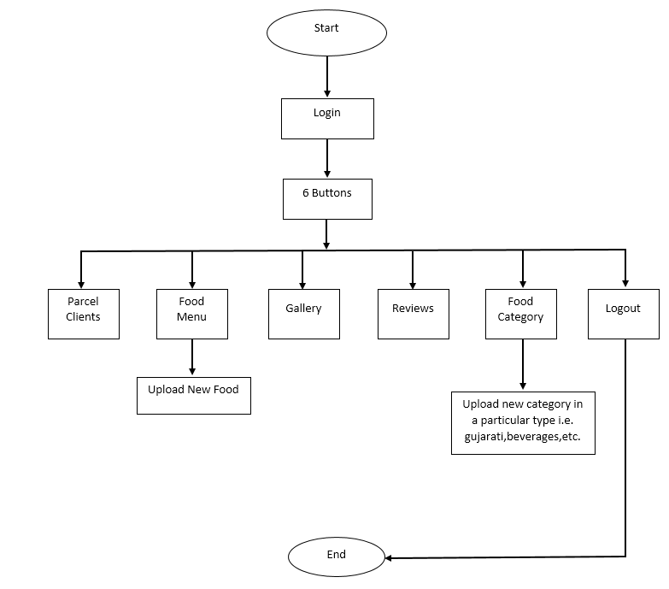**Admin Side:**

**Client Side:**

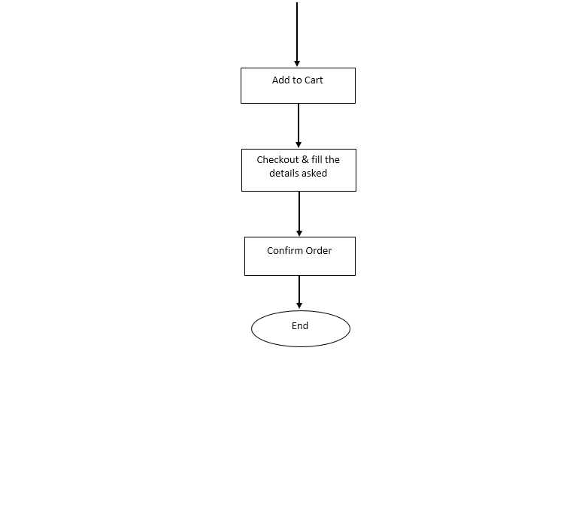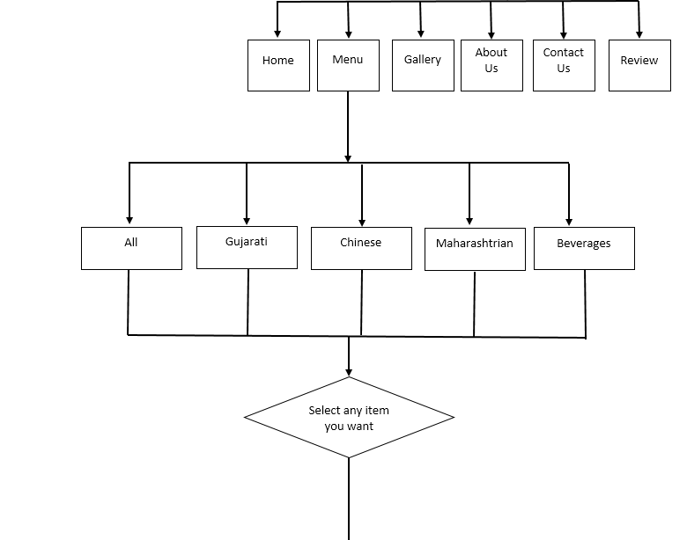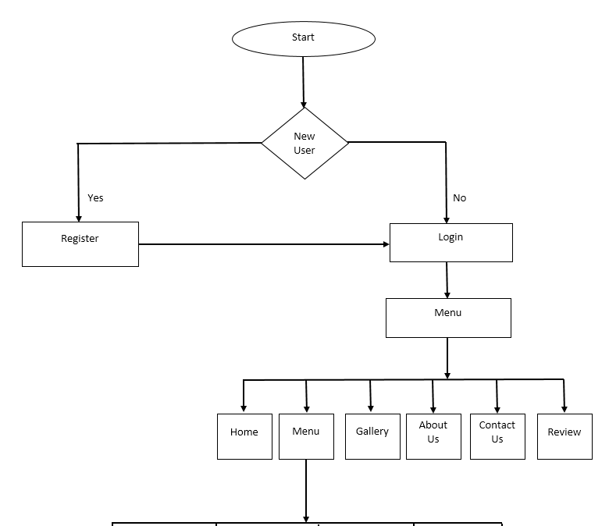

**3.2 RESEARCH METHODOLOGY**

Research is “a scientific and systematic search for pertinent information on a specific topic” (Kothari, 2004). The research methodology is a process used to collect information and data for the purpose of making decisions. There are broadly two approaches for conducting research. Those are: 1) Quantitative analysis 2) Qualitative Analysis. For developing the system, combined method has been applied. A systematic approach should be used for conducting any research to find the solution of the problem in systematic way. For this purpose, the research methods have been applied based on waterfall model.

**Initial**

**Study**

**Data**

**Collection**

**Analysis**

**Implementation**

**Critical Analysis**

**of the System**

**Figure**

**3**

**:**

**Steps of the research methods in Waterfall model.**

There are different models for research. Among them, waterfall model is chosen as it is easy to understand and implement. Hence, many beginners use this methodology for research (Dawson, 2009). Hence, this methodology is used for research in this project. Following steps have been used to formulate the hypothesis and determining project requirements:

**Initial Study**

This is the first step of the research. In this step, different topics and subject area has been reviewed to find problem. After setting the goal to developing restaurant system, the study has been narrowed to online food ordering system.

**Data Collection**

Once the goal was set, data collection process began to get information about the online food ordering system history and past works on this domain. Following methods have been used for data collection:

* **Literary Analysis:** Literatures have been reviewed and critically analysed to find what kind of works have been suggested in past. These works helped in finding the shortcomings of past solutions and defining the aim and objectives of the project. Mostly, primary data has been collected to serve the purpose. But in some cases, secondary data is also used.
* **Observation:** Number of restaurant websites have been reviewed to find the current trend in developing web application for restaurants. Along with this, typical restaurant ordering system has been reviewed to get an insight of online order processing system.

**Analysis**

After data collection, an overview on the system has been gained. Then different methods (Data Flow Diagram, Entity Relationship Diagram etc.) of Structured System Analysis & Design Methodology (SSADM) is used to analyse the system and make logical structure for it.

**Implementation**

After getting the logical structure of the system, the implementation step began. In this step, the logical structure converted to physical architecture through coding and development of the system. The frontend and backend of the system has been developed and tested.

**Critical Analysis of the System**

After implementation, the system has been critically evaluated to understand if it meets the requirements. Then the result is analysed. In this step, conclusion and future recommendation has been made.

**3.3 SYSTEM DEVELOPMENT METHODOLOGY**

For developing any information system, a System Development Methodology should be used which will provide a structured way for development of an IT based systems. SDLC refers to System or Software Design Life Cycle. It is phases of processes taken down to build a system properly.

The main aim of SDLC process is to help provide a system that is effective, cost-efficient, and of high quality. SDLC methodologies typically has the following stages: Analysis (requirements and design), construction, testing, release, and maintenance (response). But the phases can be changed in deferent SDLC mythologies. There are many software developments models for different types of projects. In following lines, only popular three of them will be discussed.

**Waterfall**

The waterfall model is a well-known structured methodology for software development. The whole process of system development is divided into distinct phases. The model has been introduced in 1970s. Every phase has a unique output. It was the first SDLC model to be used widely. So that, sometime it is referred to Waterfall by SDLC. The waterfall model is used when the system requirements are well known, technology is understood and the system is a new version of an existing product (Dennis, Wixom and Roth, 2012).

Mainly there are six phases in Waterfall model. If there is a problem faced in any phase of the cycle, the system goes to the previous phase. The phases of Waterfall method are:

**Requirements Gathering & Analysis:** In this phase, all possible requirements of the system are captured and documented in a requirement specification doc.

**System Design:** The requirements documented in previous phase are studied in this phase and the system design is prepared.

**Implementation:** With inputs from system design, the system is developed in several unites. Then the units are tested.

**Integration & Testing:** The units of the program developed in previous phase are integrated into a system. Then the whole system is tested.

**Deployment of the System:** When the all kind of testing is done, the product is deployed in the customer environment.

**Maintenance:** There are some issues which are found in the client environment.

Patches are released to fix those issues.

**System Prototyping**

Prototyping is a Rapid Action Development (RAD) method. In this method, the analysis, design and implementation phases performed concurrently and repeatedly in a cycle until the system is completed. With this methodology, the basics of analysis and design are completed. Then the work on the system prototype begins immediately. So that, many bugs and problems remained on the system. After that, the users or project sponsors provide comment on the system. Then, the system is reanalysed, redesigned and implemented based on feedbacks. This process continues until the users or project sponsors satisfied with the system (Gould, 2016).

**Agile Methodology**

Agile is an iterative and incremental development model. The Agile methodology is initiated in 2001 at a conference held in Utah, USA. The required software starts with a simple design, then to code small functions and modules. The work on these functions and modules is done in weeks for each life cycle which is called increment or sprint. In these sprints, errors to be recognised, and customer feedbacks to be incorporated into next design of the next increment (Ben-Zahia and Jaluta, 2014).

There are many models related to this methodology. The most famous ones include Scrum, lean, and Extreme Programming (XP).

**Rational for Selected SDLC**

There are different criteria for selecting appropriate SDLC for developing an IT system, because none of the SDLCs is best. Every SDLC has own advantages and disadvantages. So, the SDLC should be chosen carefully based on the type of the project. Dennis, Wixom and Roth (2012) discussed about different criteria for selecting the appropriate development methodology for a project. SDLC selection criteria provided by them is shown in the table below*.*

**Table 2: Comparison between SDLCs based on different criteria (Dennis, Wixom and Roth, 2012).**

|  |  |  |  |  |
| --- | --- | --- | --- | --- |
| **Usefulness in Developing System** | Waterfall |  | System  Prototyping | Agile  Development |
| **With unclear user requirements** | Poor |  | Excellent | Excellent |
| **With unfamiliar technology** | Poor |  | Poor | Good |
| **That are complex** | Good | | Poor | Poor |
| **That are reliable** | Good | | Poor | Good |
| **With short time schedule** | Poor | | Excellent | Excellent |
| **With schedule visibility** | Poor | | Excellent | Good |

*Table 2* illustrates that agile development is the best solution when the time is short, deadline is visible and the system should be reliable. It also has excellent performance when the requirements of system is not clear. Its performance is poor when the system complex. However, the system that is going to be built is not a complex system and the system should be developed within a short time. Therefore, it has been considered that agile methodology is the best SDLC for making the system.

On the other hand, Waterfall methodology is good for developing complex and reliable system. But its performance is poor when the schedule is short and deadline is visible. The System Prototyping method has an excellent performance with unclear requirements and within short time schedule. So, it could be a good choice for building this restaurant system. But the reliability of product developed with System Prototyping is poor. No one wants to build a system that he or she cannot rely on. In these criteria, Agile Development provides good result. So, the Agile Methodology has been chosen as the software development methodology for the system.

There are many models of implementing Agile Methodology. Extreme Programming (XP) has been chosen. Extreme Programming (XP) model has four stages for developing a project, as the figure illustrates below.

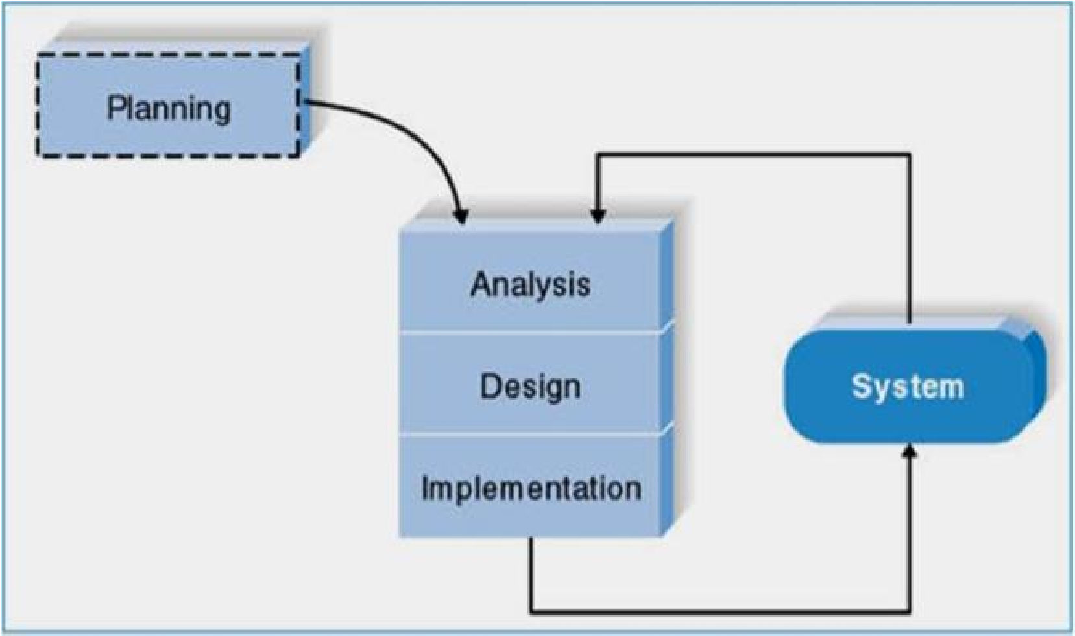

**Figure 4: Phases of Extreme Programming (XP) (Dennis, Wixom and Roth, 2012).**

As the figure above shows, there are mainly four phases in Extreme Programming method. These phases are discussed below:

* **Planning:** Extreme Programming starts with the planning stage. In this phase, the requirements for the system have been collected and documented. In this step, the plan, time, and costs of carrying out the iterations is prepared.
* **Analysis:** In this phase, the logical model of the system has been developed. SSADM is used to make the logical structure of the system. A bottom-up approach is used for analysis of the system, as there is not any previous system. The system will be developed from scratch. Along with these, the user interface requirements are also analysed.
* **Design:** In this phase of the SDLC, the logical model of database and the interface of the system is designed. The normalisation of the database schema is done in this phase.
* **Implementation:** In this phase, the system has been implemented through coding. As extreme programming is an iterative method, it is possible to use test driven development method using unit testing. After the system has been developed, the end-to-end testing (black box testing, user acceptance testing) will be used to evaluate the system. It should be kept in mind that analysis, design and implementation phases are iterative phases. After completing one iteration, feedback has been taken. Then all the phases began for the next iteration.

**3.4 REQUIREMENTS & DESIGN**

This chapter illustrates the approaches taken to design the system for restaurant. The chapter first addresses different types of requirements of the system. Then it discusses about the system design and gives an overview of the systems processes. Then, the database schema of the system is illustrated. Lastly, the user interface design has been developed.

**Requirements Elicitation**

The requirements of a system are characteristics of a system it needs to have. The requirements have been collected in the planning phase of the SDLC. Different kinds of data collection methods have been utilised to obtain the requirements of the system.

**Functional Requirements**

According to International Institute of Business Analysis (IIBA), functional requirements are “the product capabilities, or things that the product must do for its users” (Dennis, Wixom and Roth, 2012). Following are the functional requirements of the project:

* The application must have user registration and login option.
* The Application must have a shopping cart for ordering foods.
* The application must have admin registration and login system.
* The application must have password recovery system with email address for users and admins.
* The application must have menu add and edit options for admin.

**Non-Functional Requirements**

International Institute of Business Analysis (IIBA) defines non-functional requirements as “the quality attributes, design, and implementation constraints, and external interfaces which a product must have” (Dennis, Wixom and Roth, 2012). Following are the non-functional requirements of the project.

* The application must have a user interface.
* The user interface must be mobile-friendly.
* Exception handling methods must be used.
* Users should get confirmation and warning message.

**Process Modelling**

Process modelling is used in a project to depict the processes of data in an application.

The restaurant application will be developed and implemented using Model-ViewController (MVC) design pattern. These processes are mostly implemented as business logic in application controllers. There are different tools for process modelling in SSADM. Context diagram will be used to model the processes of the system.

**Context Diagram (CD)**

Context diagrams define “how the business process or computer system interacts with its environment” (Dennis, Wixom and Roth, 2012). Context diagrams are used early in a project to describe the entities of the system. It shows the external entities and data flows into and out of the system.

**User**

**Admin**

**Restaurant System**

Menu request

Menu list

Food order

Confirmation

Login request

User information

Adding menus to cart

Cart items list

Menu list

Menu update request

Confirmation

Request for order list

Order list

Details of new menu

Updated menu list

Request menu list

**Figure 5: Context diagram of the system.**

The above context diagram shows the processes of two entities, User and Admin, with the restaurant system. Both of the entities have four processes with the system.

**CHAPTER 4: HARDWARE & SOFTWARE REQUIREMENTS**

**4.1: HARDWARE REQUIREMENTS:**

**Processor:** Celtron 500MHZ or any PENTIUM Processor

**RAM:** 2 GB or Above

**Hard Disk Capacity:** Minimum Requirement is 80 GB

**Display Type:** Standard VGA or SVGA card

**4.2: SOFTWARE REQUIREMENTS:**

**Frontend:** HTML, CSS, JavaScript

**Backend:** PHP, SQL

**4.3: FRONTEND AND BACKEND IN THE PROJECT:**

**HTML, CSS, JavaScript - Frontend**

**PHP, SQL - Backend**

HTML, CSS & JavaScript is used in frontend and PHP, SQL is used in backend.

Frontend- It is the GUI page which is displayed which consists of buttons, labels, etc.

Backend- It is the place where the data is stored.

So in our project we have created frontend using HTML, CSS, JavaScript and Backend using PHP, SQL.

**4.3.1: Advantages of HTML and CSS:**

HTML which stands for Hypertext Markup Language is the predominant markup languages for web pages. HTML is the basic building block of Web Pages. This is written with HTML in the form of HTML elements consisting of tags, enclosed in anglebrackets (like <html>), within the web page content. HTML tags normally come in pairs like <hland </hl>. The first tag in a pair is the start tag, the second tag is the end tag (they are also calledopening and closing tags). In between these tags web designers can add text, tables, images, etc.the purpose of a web browser is to read HTML documents and compose them into visual oraudible web pages. The browser does not display the HTML tags, but uses the tag to interpret thecontent of the page.HTML allows images and objects to be embedded and can be used to create interactive forms. Itprovides a means to create structured documents by denoting structural semantics for text such asheadings, paragraphs, lists, links, quotes and other items. It can embed scripts in languages suchas JavaScript which affect the behavior of HTML WebPages. Web browsers can also refer toCascading Style Sheets (CSS) to define the appearance and layout of text and other material. TheW3C, maintainer of both the HTML and the CSS standards, encourages the use of CSS overexplicitly presentational HTML markup.

**4.3.2: Advantages of PHP:**

PHP is a general-purpose scripting language originally designed for web development to produce dynamic web pages. For this purpose, PHP code is embedded into this system’s pages interpreted by a web server with a PHP processor module, which generates the web page document. PHP can be deployed on most web servers and as a standalone interpreter, on almost every operating system and platform free of charge. A competitor to Microsoft’s Active Server Pages (ASP) serverside script engine and similar languages, PHP is installed on more than 20 million websites and 1 million web servers. PHP was originally created by Rasmus Lerdorf in 1995. The main implementation of PHP Group and serves as the de facto standard for PHP as there is no formal specifications. PHP is free software released under the PHP license.

**CHAPTER 5: IMPLEMENTATION**

**Admin side:**

**login.php**

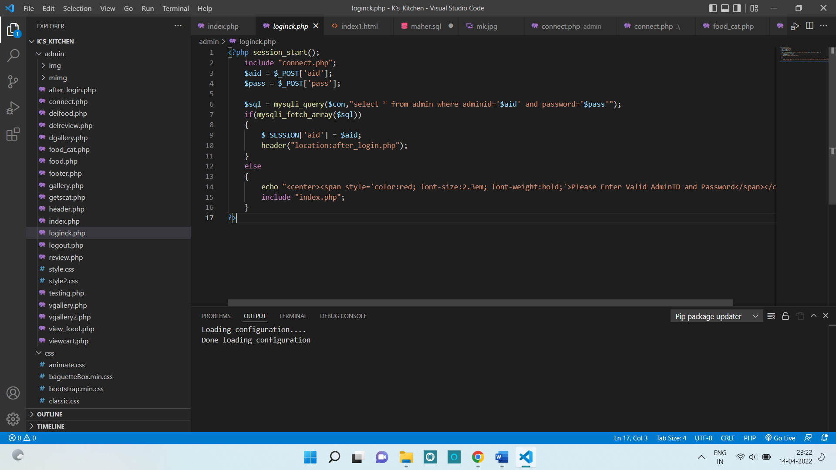**User Side:**

**login.php**

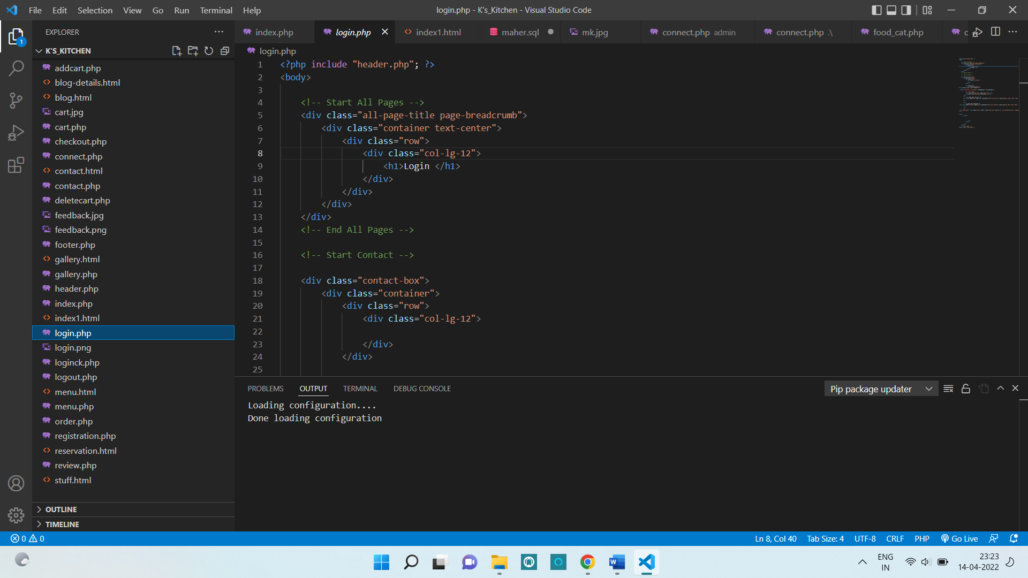

**index.php**

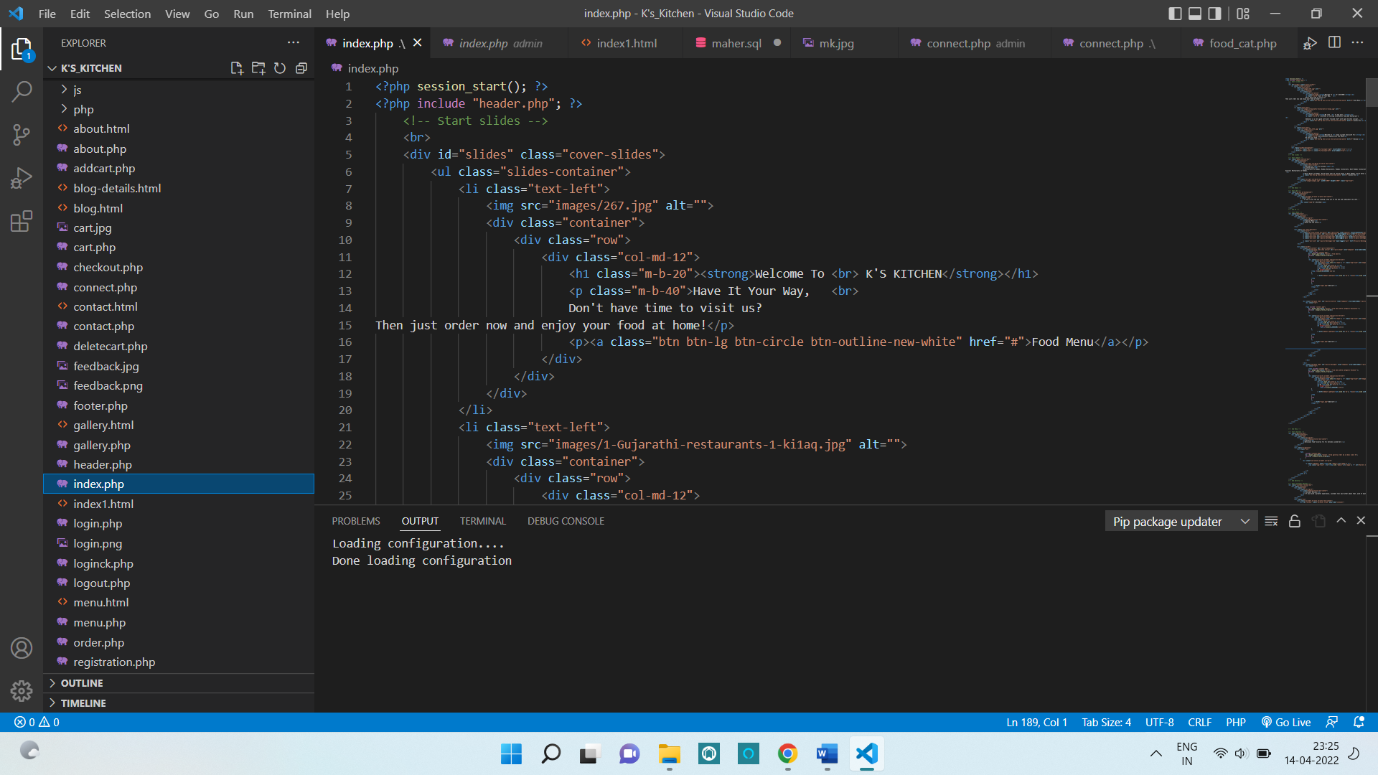

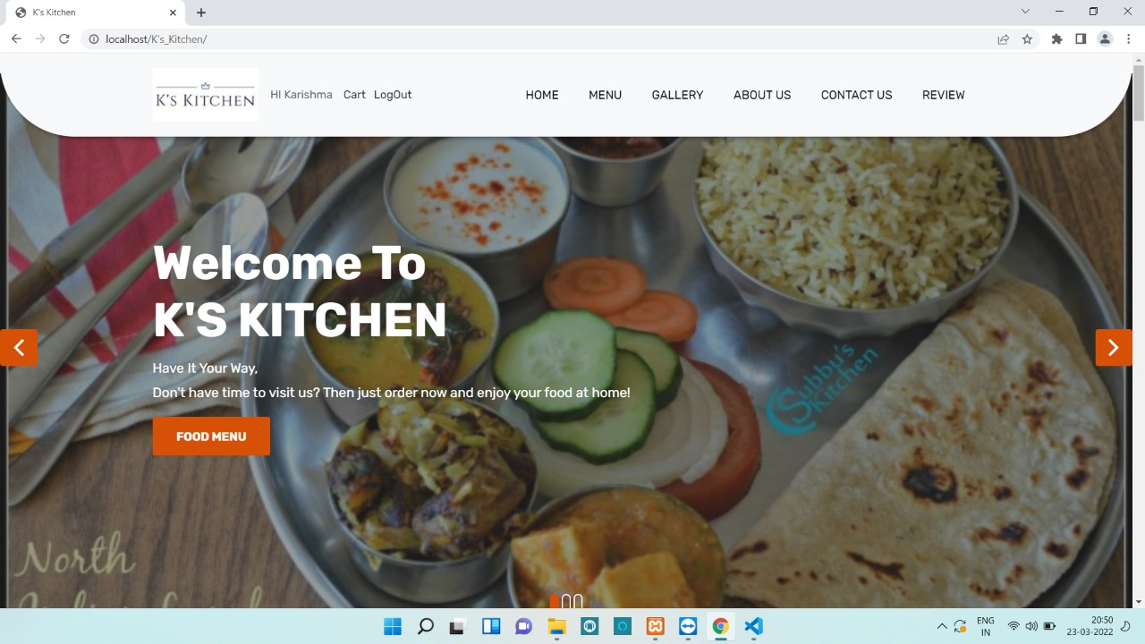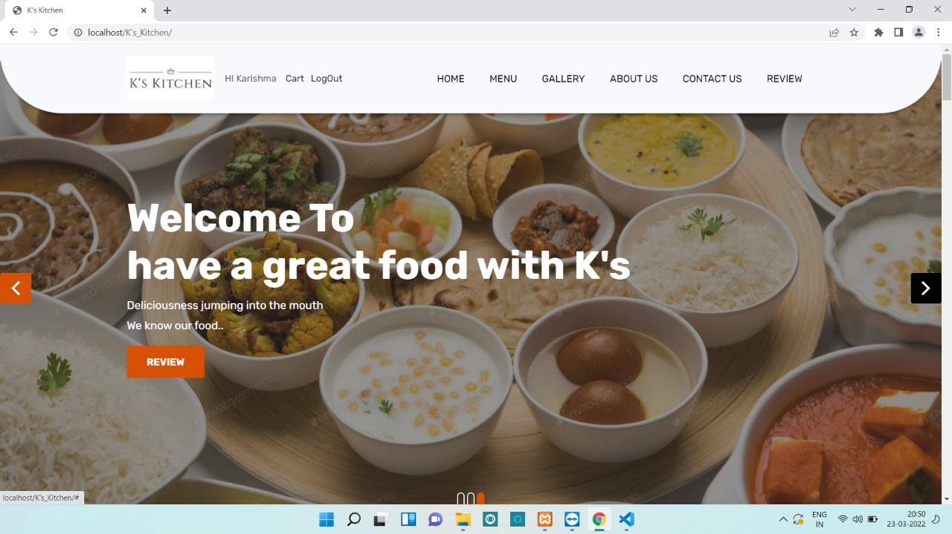**CHAPTER 6: RESULTS AND DISCUSSION**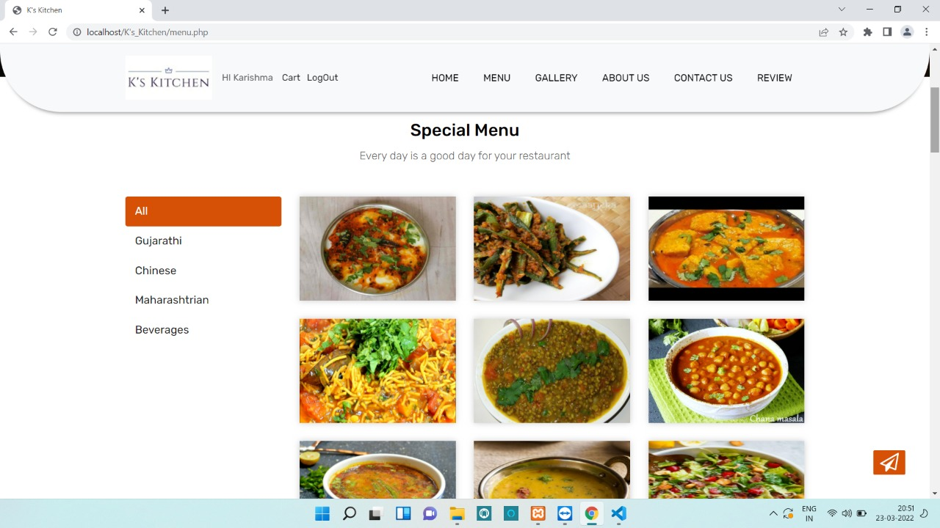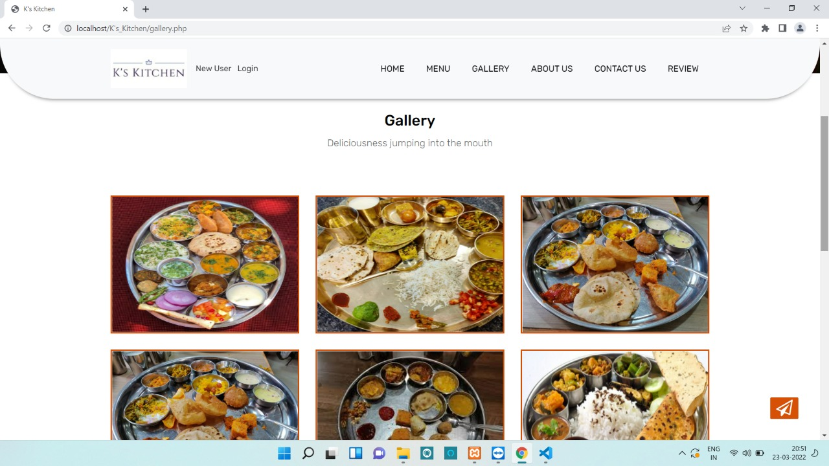

**Figure 6.1: Home Page**

**Figure 6.2: Home Page**

**Figure 6.3: Menu**

**Figure 6.4: Gallery**

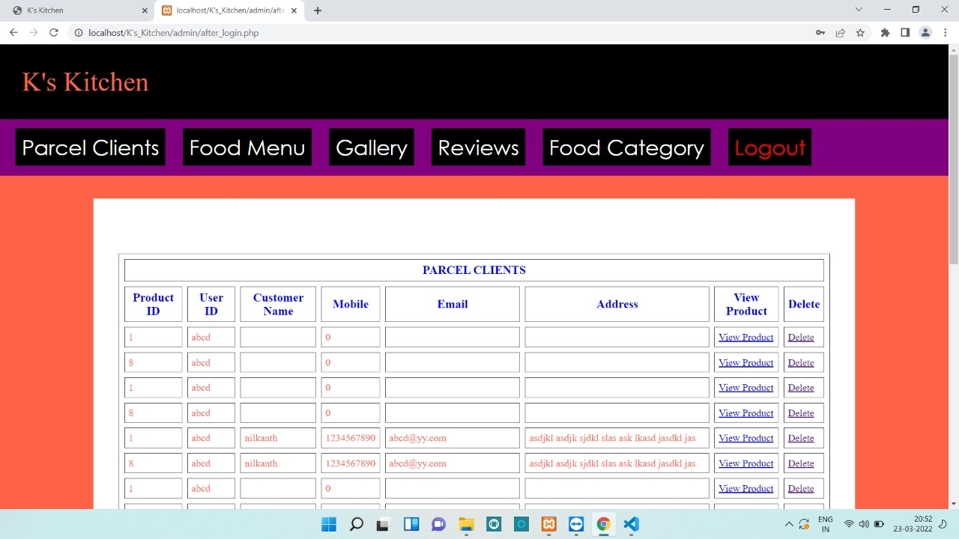

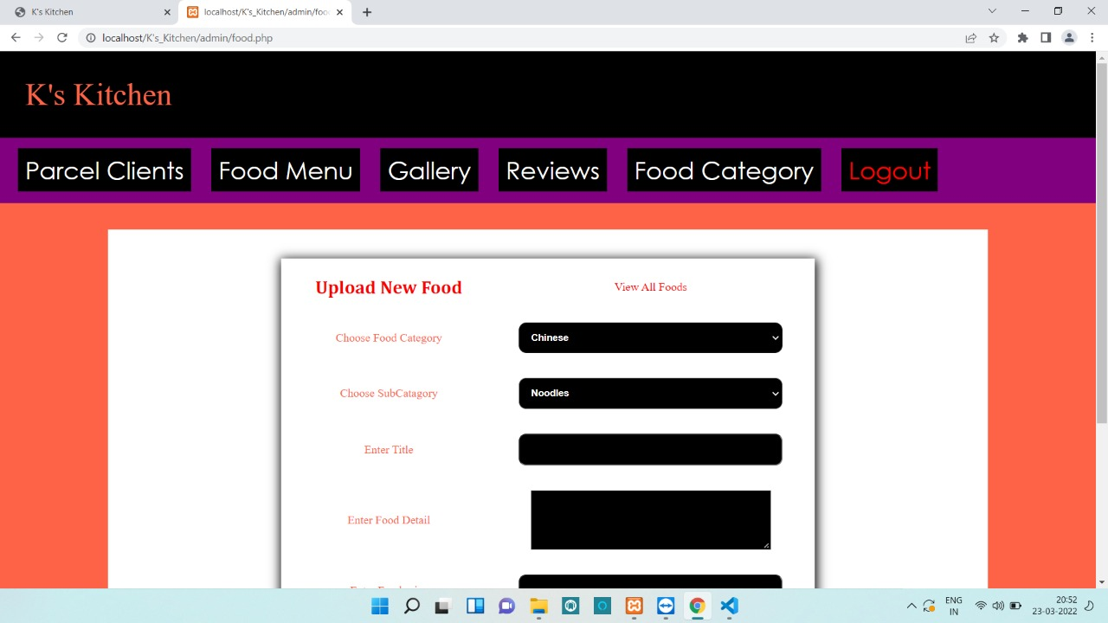

**Figure 6.6: Food Category section to add new food on Admin Side**

**Figure 6.5: Client’s Parcel Details stored on Admin Side**

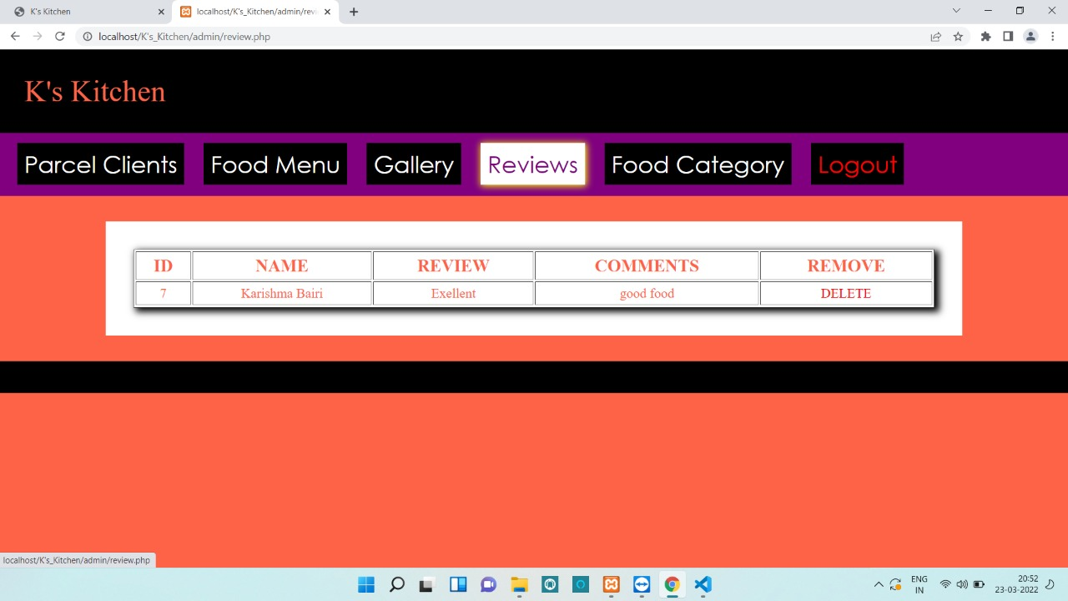

**Figure 6.7: Review Section on Admin Side consists of feedback given by customers**

**CHAPTER 7: CONCLUSION**

This website is developed where the customers can make an order for the food and avoid the hassles of waiting for the order to be taken by the waiter. Using this website, the end users register online, read the E-menu card and select the food from the e-menu card to order food online. Once the customer selects the required food item the chef will be able to see the results on the screen and start processing the food. This application nullifies the need of a waiter and reduces the workload of the waiter. The advantage is that in a crowded restaurant there will be chances that the waiters are overloaded with orders and they are unable to meet the requirements of the customer in a satisfactory manner. Therefore by using this website, the users can directly place an order for food online.

In conclusion, this Restaurant Website is proposed which is useful in small family run restaurants as well as in places like college cafeteria, etc. This project can later be expanded on a larger scale. It is developed for restaurants to simplify their routine managerial and operational task and to improve the dining experience of the clients. This also helps the restaurant owners develop healthy customer relationships by providing reasonably good services. The system also enables the restaurant to know the items available in real time and make changes to their food and beverage inventory based on the orders placed and the orders completed.

**REFERENCES**

1. <https://www.restaurant-website-builder.com/advantages-of-having-a-website-for-a-restaurant>
2. <https://www.researchgate.net/publication/259525214_A_review_of_literature_on_restaurant_menus_Specifying_the_managerial_issues>
3. <https://www.academia.edu/40212048/Restaurant_Management_System_Third_Year_Project_Report>